MYP 4 Pythagorean Theorem – Criterion D

1. The Pythagorean Theorem
- Applies to right-angled triangles (one angle = 90°).
- Formula:
a² + b² = c²
Where:
- a and b = shorter sides (legs)
- c = hypotenuse (longest side, opposite the right angle)

2. Identifying the Hypotenuse
- The hypotenuse is always the side opposite the right angle.
- It is the longest side of the triangle.
- Each right-angled triangle has its own hypotenuse.
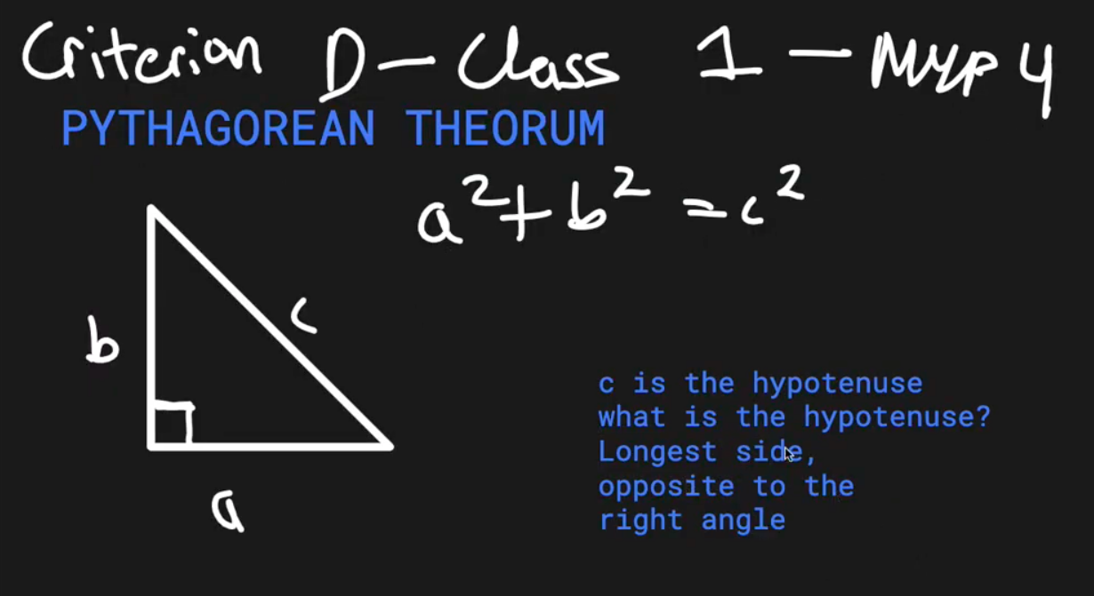

3. Example 1 (Basic)
Right angled triangle with side lengths:
- a = 3cm, b=4cm, c=x.
x² = 3² + 4²
x² = 9 + 16 = 25
x = √25 = 5cm
Answer: Hypotenuse = 5cm
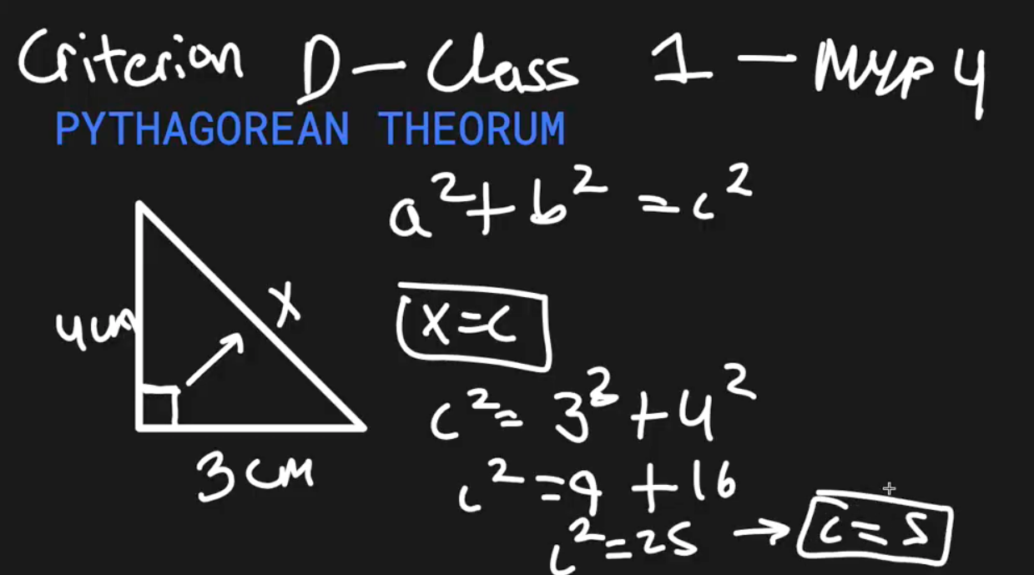

4. Example 2 (Unknown with Variable)
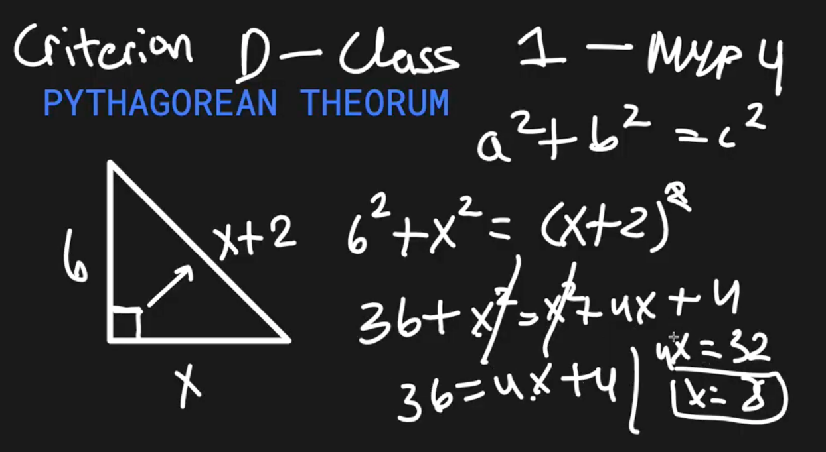
Triangle sides: a=6cm, b=x, c = x+2.
6² + x² = (x+2)²
36 + x² = x² + 4x + 4
Cancel x² from both sides:
36 = 4x + 4
4x = 32 ⇒ x = 8cm

Answer:
b = x, therefore b = 8cm.
c = x+1, therefore c = 8+1 = 9cm.

5. Example 3 (Two Triangles)
- Larger triangle with hypotenuse = 37cm.
- Smaller triangle inside with hypotenuse = 13cm.
- Need to find x and y.
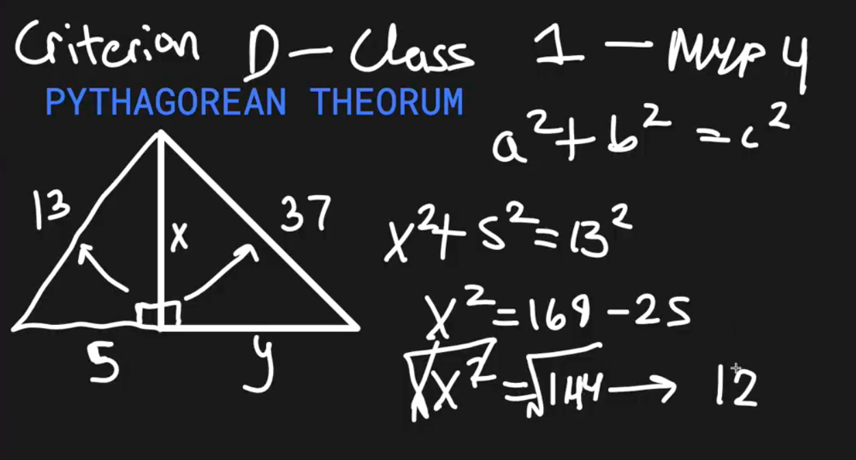
Step 1: Solve for x (smaller triangle):
x² + 5² = 13²
x² + 25 = 169 ⇒ x² = 144 ⇒ x = 12cm
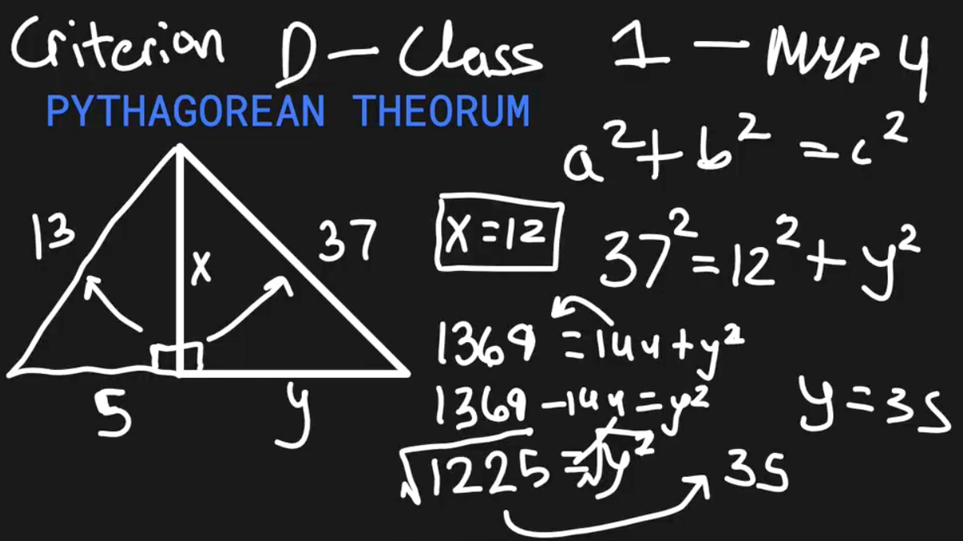
Step 2: Solve for y (larger triangle):
12² + y² = 37²
144 + y² = 1369
y² = 1369 - 144
y² = 1225
y = √1225 = 35cm

Answer: x = 12cm, y = 35cm.

6. Example 4 (Word Problem – Ladder Against Wall)
- Ladder leans against a house:
  - Height reached on wall = 12 m
  - Distance from wall = 5 m
  - Find ladder length.
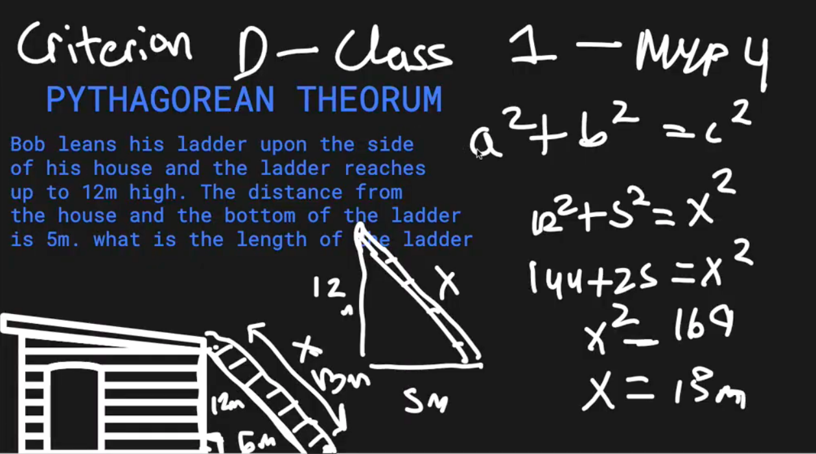
Right-angled triangle:
- a=12m, b=5m, c=x.
x² =12² + 5² = 144 + 25 = 169
x = √169 = 13m
Answer: Ladder length = 13 m.

7. Recap
- The Pythagorean Theorem is used to find missing sides in right-angled triangles.
- Always identify the hypotenuse correctly.
- Formula:
a² + b² = c²
- Can be applied to algebraic problems and real-life word problems.

