MYP 4 Equation of a Line – Criterion A

1. What is a Line?
- A line is an infinite set of points extending in both directions.
- A line segment has two endpoints and is finite.
- In graphs, we usually draw segments, but they represent lines.

2. Equation of a Line
- General form: y = mx + c
- m = gradient (slope)
- c = y-intercept (where the line crosses the y-axis)

3. Gradient (Slope)
- Formula:
m=(y₂−y₁)/(x₂−x₁)
- Interpreted as rise over run (vertical change ÷ horizontal change).

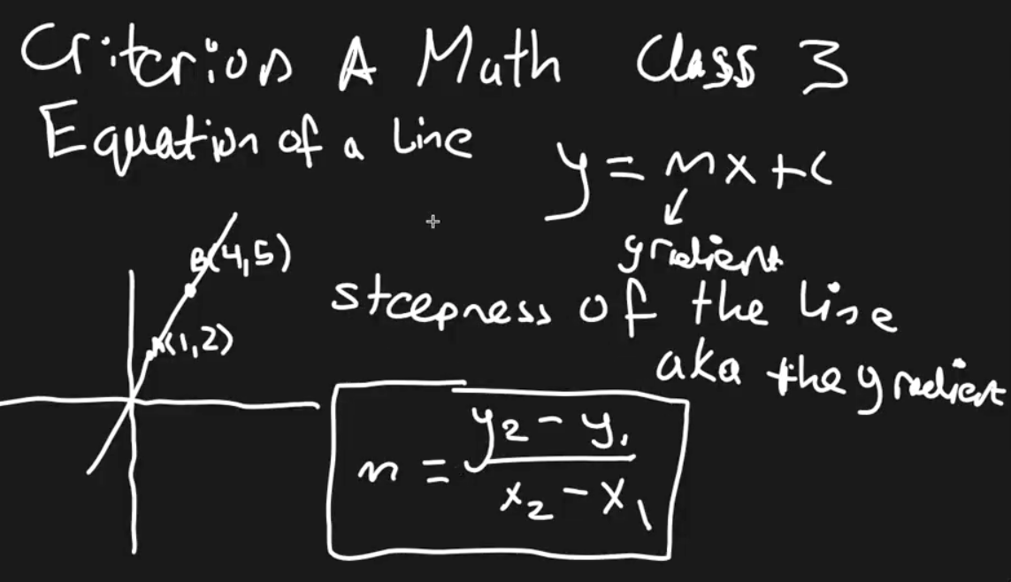

Example:
Points: (1,2) & (4,5)
m = (5−2)/(4−1) = 3/3 = 1

4. Finding the Y-Intercept
- Use the equation y=mx+c
- Plug in one known point and the gradient to solve for c.

Example:
Gradient m=1, point (4,5):
Equation of the lines:
y = 1x + c
Plug in the values for x and y:
5 = 4(1) + c ⇒ c = 1
Final equation:
y=x+1
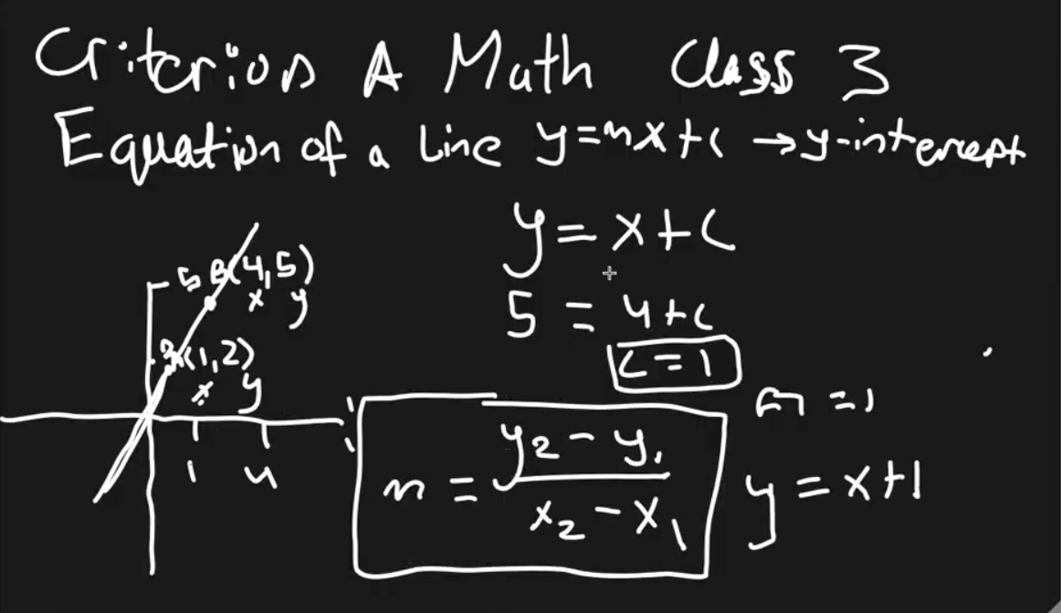

5. Word Problem Example
Gradient m=2, point (5,3).
Equation:
y= 2x+c
Substitute points:
3 = 2(5) + c ⇒ c =−7

Final equation:
y=2x−7

6. Parallel and Perpendicular Lines

Parallel Lines
- Never intersect.
- Property: Same gradient.
Example:
Line A gradient = ⅓ ⇒ Line B (parallel) also has gradient ⅓ ​.

Perpendicular Lines
- Meet at 90°.
- Property: Gradients are negative reciprocals.
m1×m2=−1m_1 \times m_2 = -1m1​×m2​=−1
Reciprocal: Flip numerator & denominator.
Negative reciprocal: Reciprocal × −1-1−1.
Examples:
- Reciprocal of ⅓ = 3/1
- Negative reciprocal = −3/1
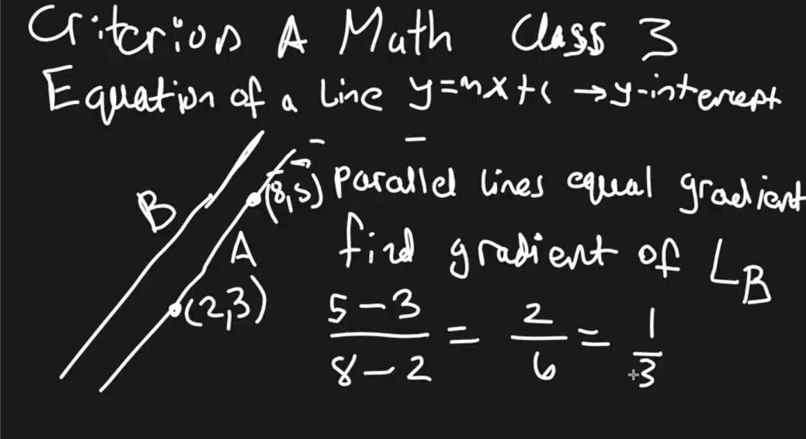

Example with Perpendicular Lines
Line A passes through (−3,−1) and (11,3) Line B is perpendicular to line A. Find the gradient of Line B.
mA= (3−(−1))/(11−(−3)) = 4/14 = 2/7

Line B ⟂ Line A:

mB= −7/2

