MYP 4 Binomial Expansion – Criterion A

Definition: Binomial
- A binomial is an expression with two terms inside a bracket, e.g.
  - a + b
  - a − b
Binomial Expansion: multiplying out and simplifying these terms.

Three Main Cases
- (a + b)²
- (a - b)²
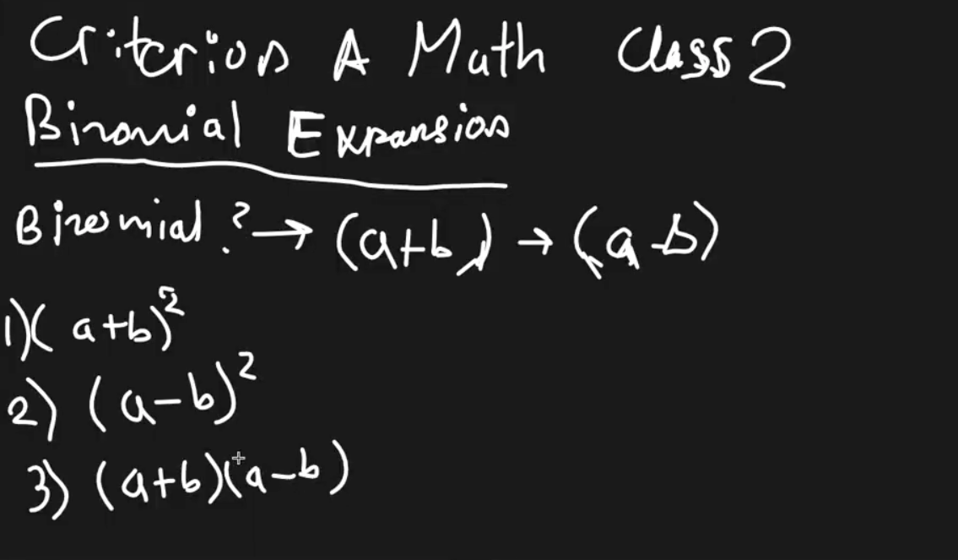
- (a+b)(a−b)

1. Expansion of (a + b)²
- Square means multiplying by itself:
(a+b)(a+b)
- FOIL Method (First, Outer, Inner, Last):
a⋅a + a⋅b + b⋅a + b⋅b
- Simplify:
a² + ab + ab + b² = a² + 2ab + b²

Example:
(x+4)² = x² + 2(x)(4) +4² = x² + 8x + 16

2. Expansion of (a−b)2(a - b)^2(a−b)2
- Multiply: (a−b)(a−b)
- FOIL:
a² − ab −ab + b²
- Simplify:
a² − 2ab + b²

Example:
(x−4)² = x² − 2(x)(4) + 4²= x² −8x +16

3. Expansion of (a+b)(a−b) — Difference of Squares
- Multiply:
a² + ab − ab − b²
- Simplify:
a² − b²

Example:
(2x+8)(2x−8) = (2x)² − 8² = 4x² − 64

Key Idea:
- Binomial expansions create predictable formulas:
  - (a+b)² = a² + 2ab + b²
  - (a-b)² = a² - 2ab + b²
  - (a+b)(a−b) = a²−b²

