MYP 4 Absolute Values – Criterion A
- Definition:
The absolute value of a number is its positive version on the number line.
  - |−1| = 1
  - |−3| = 3
  - |4| = 4
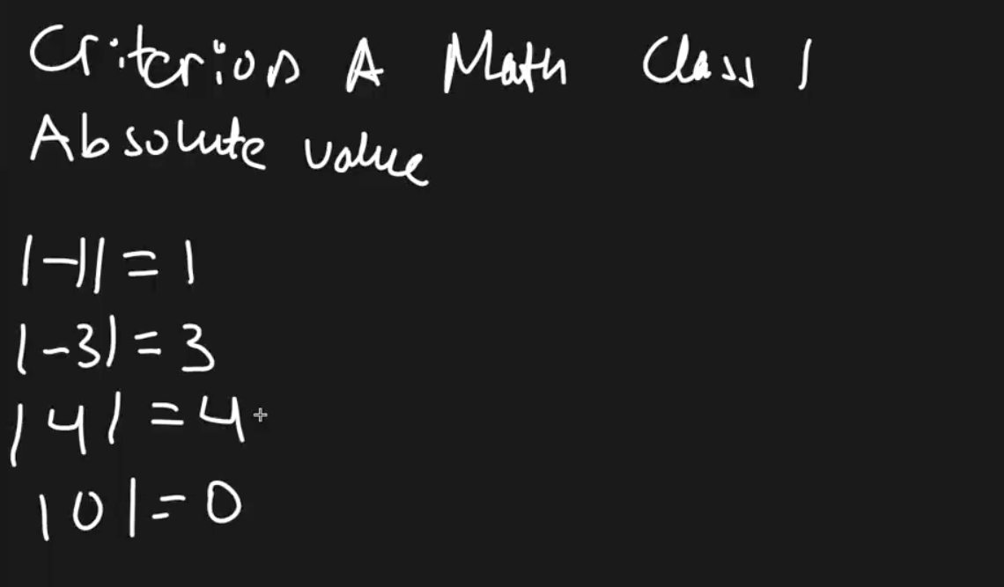
  - |0|=0

Example 1: Solve |x−1|=4
- Absolute value can represent both positive and negative results.
  - Case 1: x − 1 = 4 ⟹ x = 5
  - Case 2: x − 1 = −4 ⟹ x = −3
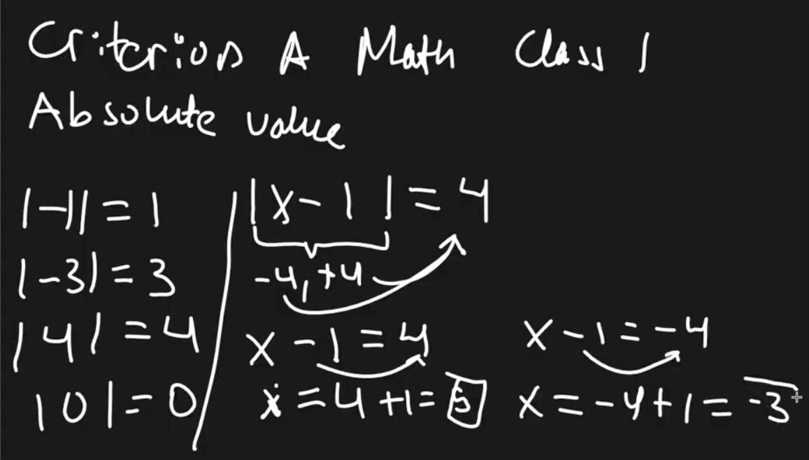
- Check solutions:
  - |5−1| = |4| = 4 ✅
  - |−3−1| = |−4| = 4 ✅
Solutions: x=5 or x=−3

Example 2: Solve |2x+5|=10
- Case 1: 2x+5=10 ⟹ 2x=5 ⟹ x = 5/2
- Case 2: 2x + 5 = −10 ⟹ 2x = −15 ⟹ x = −15/2
Solutions: x = 5/2​, x = −15/2x​
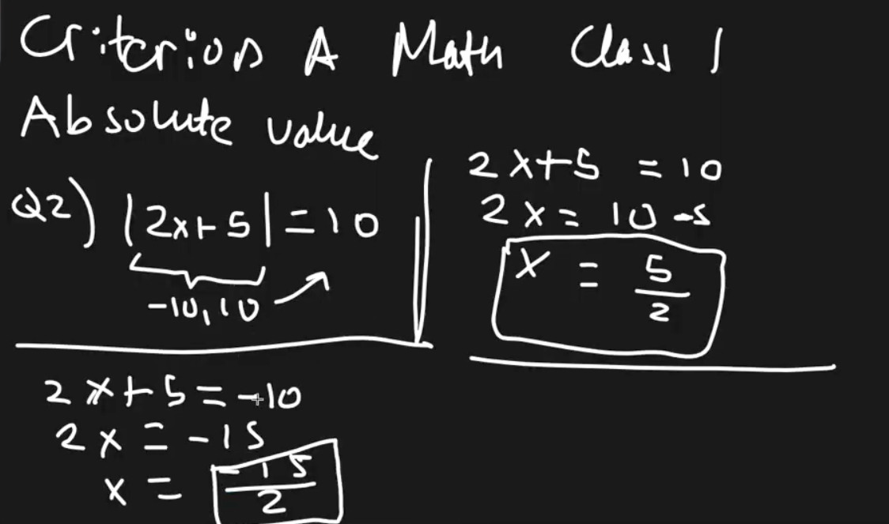

Key Idea:
- Absolute value equations often have two solutions, similar to quadratics.
- If there is only one solution, both cases result in the same value.

